Motivation Education & Training
Farmworker Eligibility Requirements for training
APPLY TODAY FOR OUR PROGRAM
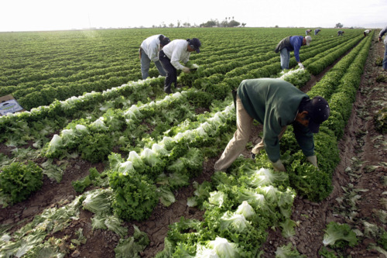 | NFJP provides job training and placement services to eligible farmworkers. To qualify as eligible, an individual must be an eligible farmworker or a dependent of an eligible farmworker, and a citizen, a national of the United States, a lawfully admitted permanent resident alien, a refugee, an asylee, a parolee, or other immigrant authorized by the Attorney General to work in the United States and male applicants must have not violated Section 3 of the Military Selective Service Act by not presenting and submitting to registration as required.
"Eligible farmworker" is a person who, during the 12-month "eligibility determination period", is a "seasonal farmworker" and whose family is disadvantaged. "Seasonal farmworker" is a farmworker who, during the 12-month "eligibility determination period", has been "primarily employed in agricultural labor" that is characterized by chronic unemployment or underemployment (WIA 167(h)94)). "Primarily employed in agricultural labor" means the farmworker depended on farm work performed within the United States or Puerto Rico for his/her support during the 12-month "eligibility determination period"; by earning at least 50 percent of his/her total income from farm work or was employed at least 50 percent of his/her total work time in farm work, by working at least 25 days in farm work or by earning at least $800 in farm work, and by receiving 50 percent or less of his/her total financial support from a parent or guardian during the "eligibility determination period". "Eligibility determination period" is any consecutive 12-month period within the 24-month period immediately preceding the date of application for enrollment in the NFJP by the applicant (WIA 167(h)(1)).
Reference: May 11, 2001 NFJP Bulletin No. 01-0X, Participant Eligibility Policy Guidance.
Please contact the office near you for eligibility verification.
Edinburg, Texas
2719 W. University Dr.
Edinburg, TX 78539
(956) 289 – 4532

Harlingen, Texas
1902 N. Loop 499, Bldg. EK, Office 203A
Harlingen, TX 78550
(956) 364 – 4985

Weslaco, Texas
1600 N. Westgate, Suite 400
Weslaco, TX 78596
(956) 969 - 6147

